INVICTUS assignment

By:- Bhavana Deshmukh

**$$STRUCTURE**

**This assignment has two major parts:**

1. Main.jsx:

It contains all the calculation and fetching of data.

1. Table.jsx

It is used to push key-value into the table for display.

* Data is fetch using Fetch function and stored distinctly.
* Key value pair is formed. As the key(f) is repeated Value(i) increases.
* Using push function all the key and its values are pushed into the table.

**$$Test Cases**

1] Home

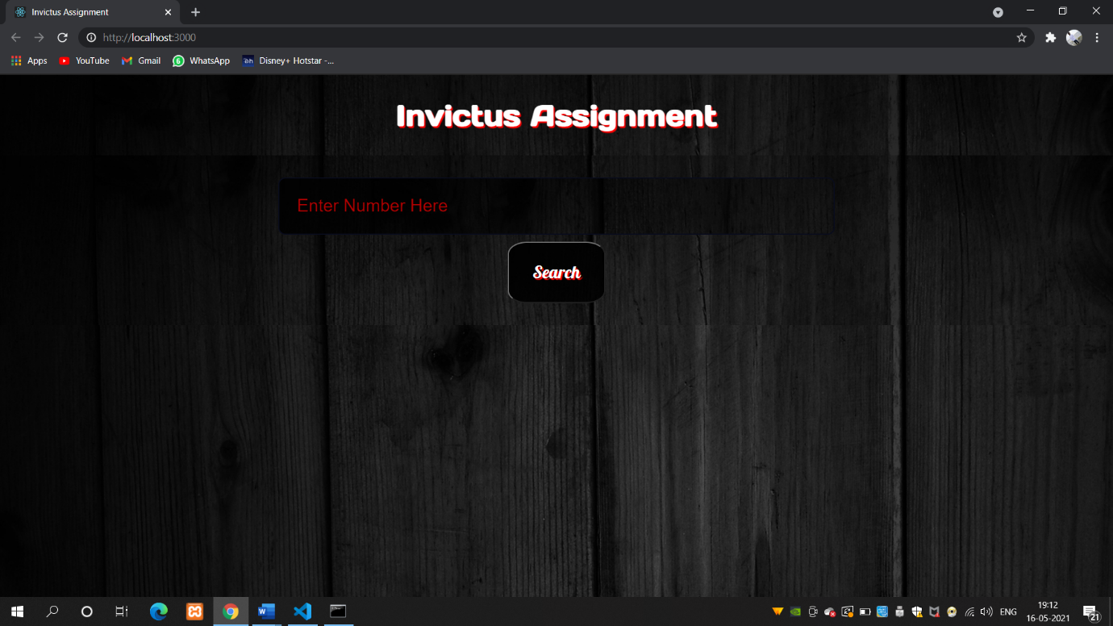

2] Input=0

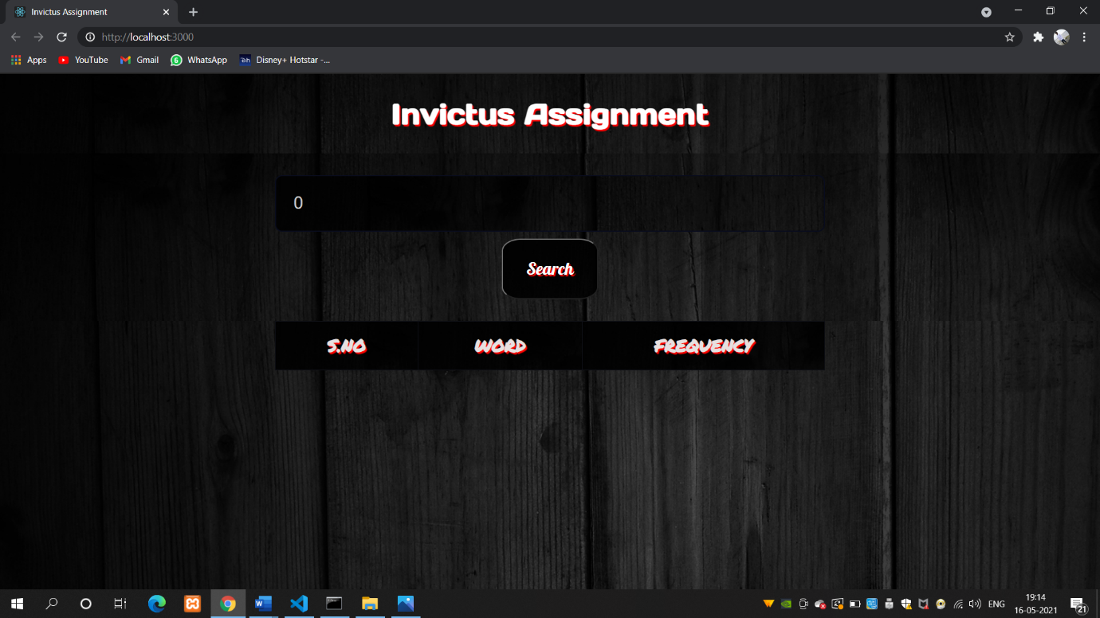

3]Input=1

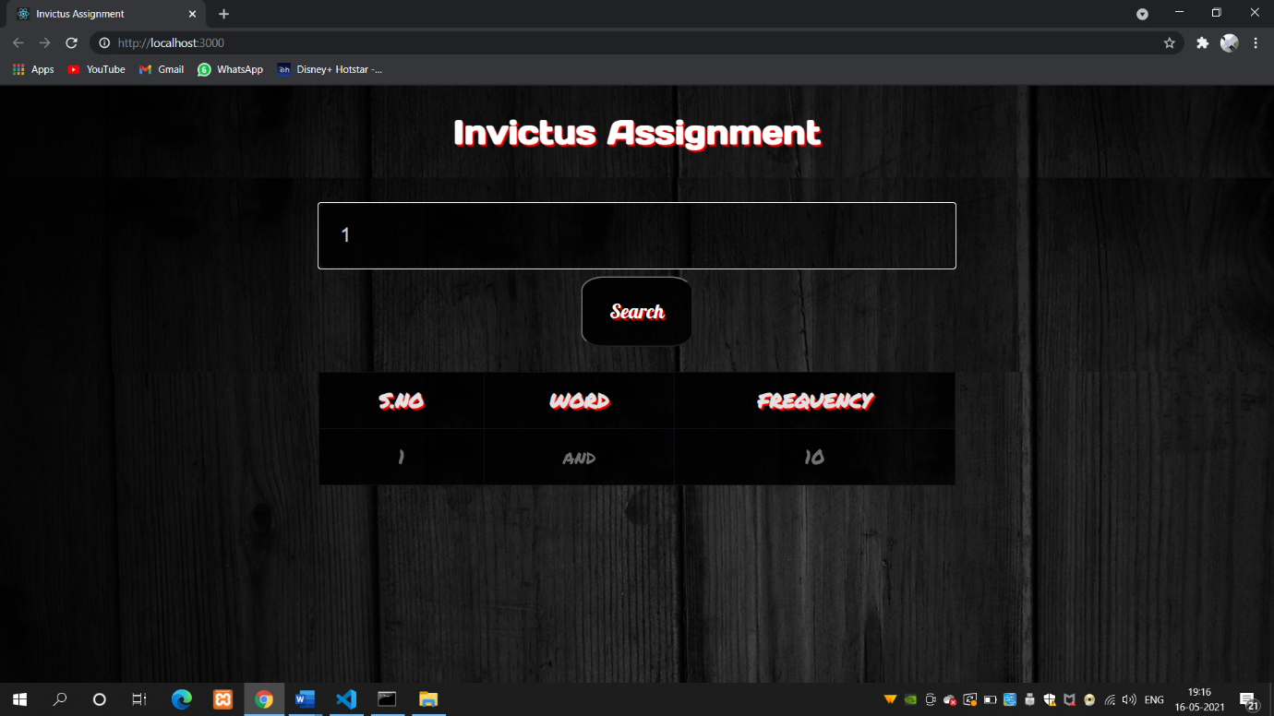

4]Input=5

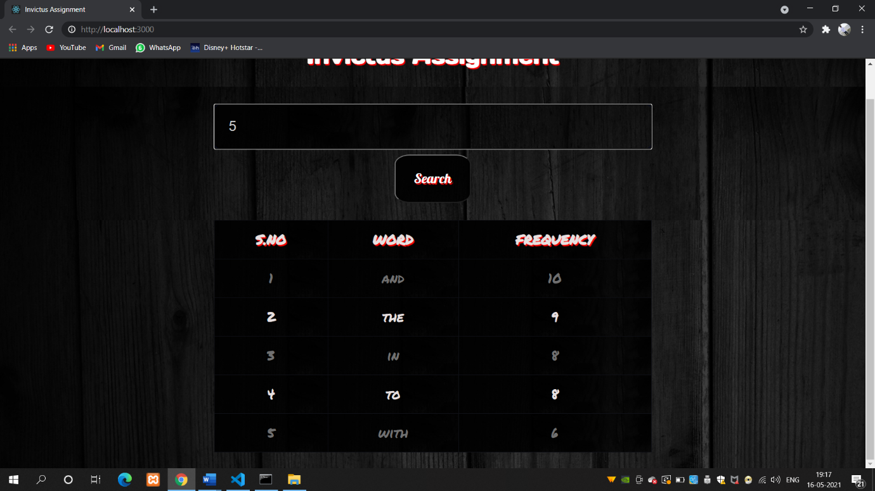

**$$Technologies used:**

* ReactJs is used to develop this assignment .
* Git is used for version control of the project.
* Sass along with CSS is used for styling.
* Fonts are fetched from google fonts.
* This assignment is deployed at …//////////////////site